Foirm Òigridh / Junior Entry  Form | 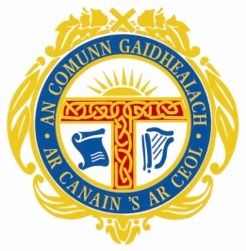

 | Mòd Ionadail...
 |  | Ainm / Name*  Ainm Càraid / Duet partner*  (If applicable)  Aois aig / Age on … | Date of Birth*
 |  |  | Date of Birth*

Sgoil / School

Seòladh / Contact Address

Còd Puist / Post Code

Seòladh Post-d / E-mail Address

Àireamh(an) Fòn / Contact Tel. Numbers
Ainm Còisir / Buidhean
/ Choir / Group Name
Ainm Stiùiriche / Conductor’s Name

Àireamh Farpaisean / Competition Numbers
(as per syllabus)

Individual |  | Duet | Choir |  |  |  | Group
£… |  | £… |  | £… |  | £…
 | Entry Fee |  |  |  | £
 | Total |  |  |  | £
Closing date for entries is ….
All own choice music must be submitted by ….

Literary Competitions - All literature entries must be submitted by …

Entry forms should be returned to:
(eg An Comunn Gàidhealach, Taigh a’ Mhorair Leverhulme, Ceàrnag Phearsabhail, Steòrnabhagh, Eilean Leòdhais, HS1 2DD. Fòn: 01851 703 487)

