
An Comunn Gaidhealach
'Ar Cànain 's ar Ceol'

MOD IONADAIL SHRUIGHLEA
STIRLING PROVINCIAL MOD
Friday 17th & Saturday 18th May 2013

2013 SYLLABUS

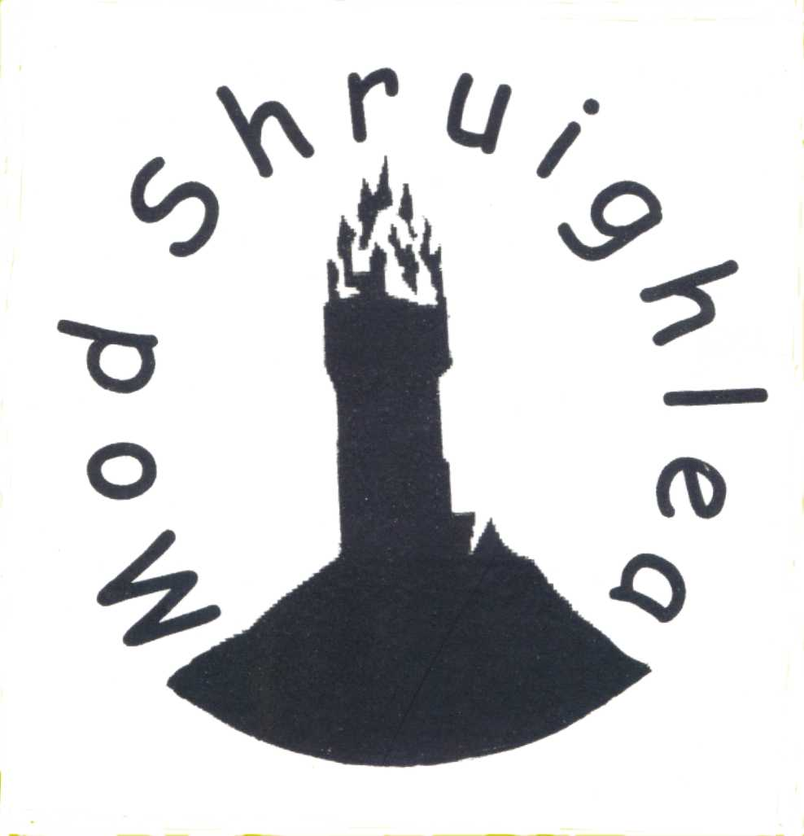

All entries to be lodged, not later than 31st March 2013, with:
Rachael Deans
46 Thorniecroft Drive
Cumbernauld
G67 4JS
07807 460653

LATE ENTRIES WILL NOT BE ACCEPTED

Tàic
The committee would like to thank the following organisations for their continued support.




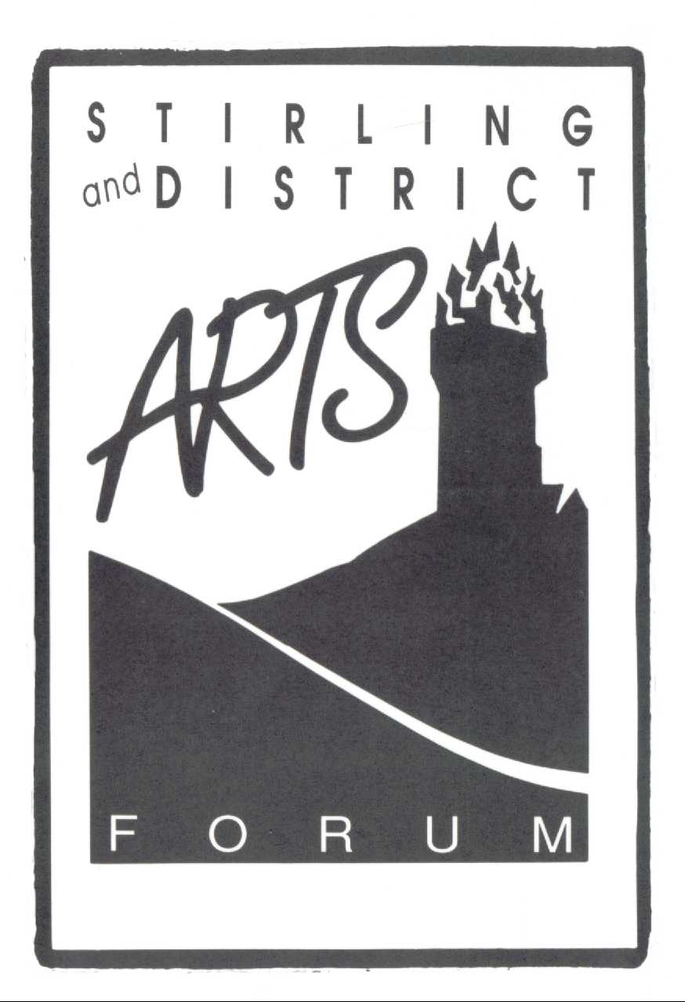
Stirlingshire Educational Trust



Fiosrachadh
Some information about the Mod.

Piping and Fiddle Competitions Friday 17th May 7pm
Venue: St Modan’s High School, Royal Stuart Way, Stirling, FK7 7WS.
Vocal, Oral & Choral Competitions Saturday 18th May Junior 9am Senior 2pm
Venue: Golden Lion Hotel, King St, & Allanpark Church Halls, Dumbarton Rd, Stirling
Admission to all competitions £2.00; Children FREE
Mod programmes: £2.00

Mod Ceilidh Dance
in ALBERT HALL Saturday 18th May 7.30pm featuring
JUNIOR & SENIOR Prizewinners and the Charlie Kirkpatrick BAND

JUNIOR SECTION

PIPING (CONFINED)

19. | Under 10 years | Chanter | March - two part: Own Choice
20. | 10 and under 12 years | Chanter | March - two part: Own Choice
21. | Under 12 years | Bagpipes | March – two part: Own Choice
22. | Under 14 years | Bagpipes | March - four part: Own Choice
23. | Under 16 years | Bagpipes | March, Strathspey & Reel: Own Choice
24. | 16 and under 18 years | Bagpipes | March, Strathspey & Reel: Own Choice
25. | Under 18 years | Bagpipes | Ceol Mor: Competitors to submit two titles of own choice.

FIDDLE (OPEN)

F1: | Under 13 years | Playing the melody of a Gaelic song (all tunes to be played twice)
F2: | 13-18 years | Playing the melody of a Gaelic song (all tunes to be played twice)
F3: | Under 13 years | Playing a Slow Air and March
F4: | Under 18 years | Playing a Strathspey and Reel

JUNIOR SECTION

(OPEN)

ORAL

LEARNERS - Recitation from Memory

1. | Boys & Girls | 5 – 8 years | An sgoilear ùr or An Cù agus am faileas
2. | Boys & Girls | 9 – 12 years | Chan eil annamsa ach truaghan or An t-uaireadair
3. | Boys & Girls | 13 – 15 years | Smuaintean an eilthirich
4. | Boys & Girls | 16 – 18 years | An aisling

FLUENT SPEAKERS - Recitation from Memory

5. | Boys & Girls | 5 – 8 years | Caraidean or "Gròc gròc", ars am fitheach
6. | Boys & Girls | 9 – 12 years | Mo Chuilean Beag or An sneachda
7. | Boys & Girls | 13 – 15 years | Ri taobh na tràghad
8. | Boys & Girls | 16 – 18 years | Cailleach na h-èibhleige

VOCAL

LEARNERS and FLUENT SPEAKERS – Solo singing and duets

9. | Boys & Girls |  | 5 – 6 years | Gille beag ò or An sù
10. | Boys & Girls |  | 7-8 years | Chuir iad mise dh'eilean leam fhìn or A' phiseag amaideach
11. | Boys & Girls |  | 9-10 years | Chì mi'n toman (Girls) S toigh leam cruinneag dhonn nam bò(Boys)  Mac òg an Iarla Ruaidh (Girls) Lag nan cruachan (Boys)
12. | Boys & Girls |  | 11-12 years | Own Choice
13. |  | Boys & Girls | 13-15 years | Own Choice
T1. |  | Boys & Girls | 13- 18 years | Traditional: One Song Own Choice
T2. |  | Boys & Girls | Under 13 years | Traditional: One Song Own Choice

16. | Boys & Girls | 16 and under 18 years | One Song: Own Choice
17. | Duet singing | Under 13 years | One Song: Own Choice
18. | Duet singing | 13 and under 18 years | One Song: Own Choice

CHORAL
Under 18 years
C1 | Unison | Two Songs: Own Choice
C2 | Two Part Harmony | Two Songs: Own Choice
C3 | Puirt a Beul | Own Choice

Prescribed pieces from 2013 Mod Books available from:
An Comunn Gaidhealach, Balnain House
40 Huntly Street
Inverness
IV3 5HR
SENIOR SECTION

(OPEN)

ORAL

26a. | Learners - Recitation from Memory | Soraidh leis na h-àrmainn ùr
26b. | Fluent Speakers - Recitation from Memory | An t-alltan
27 | Learners - Reading at sight | Piece of prose selected by adjudicator

VOCAL

28. | Female Voices | One Song from the Following Group  Gaol nam fear dubh; Tuireadh nan Hiortach; Mo robairneach gaolach; Creach na Ciadain
29. | Female Voices | One Song: Own Choice
The winner of Competition 29 will be awarded the Catriona MacIsaac Tasker Rosebowl for sincerity of expression.
The leading competitor in Competitions 28 and 29 will be awarded the Mod silver medal

30. | Male Voices | One Song from the Following Group  Cruachan Beann; Mo chailìn dìleas donn; Seo nam shìneadh air an t-sliabh; Marbhrann do Mhrs Noble
31. | Male Voices | One Song: Own Choice
The leading competitor in Competitions 30 and 31 will be awarded the Mod silver medal

32. | Male and Female Voices | One Song from the Following Group  Oran na cloiche; An t-Eilean Beag Liosach; Muile nam fuar-bheann mòr
Winner of this competition is eligible for Competition No A272 at the National Mod.

33. | Male and Female Voices | One Song Own Choice
The song must have a connection with the host district of Mòd Nàiseanta Rìoghail 2013 and may be self accompanied.

34. | Male and Female Voices | Song sung in the traditional manner: Own Choice
35. | Male and Female Voices | Puirt a Beul: Own Choice
36. | Duet Singing | One Song: Own Choice
37. | Quartets | One Song: Own Choice

CHORAL

38. | Choral Singing (Mixed) | Two Songs: Own Choice
39. | Choral Singing (Mixed) | Puirt a Beul: Own Choice
40. | Choral Singing (Ladies’ or Men’s choirs) | One Song: Own Choice

Special Competition

41 | Any Competitor | One Song Own Choice - Theme: Year of Natural Scotland
Open to solos, duets, quartets, choirs or other groups of any size, may include accompaniment. Individuals may compete in more than one group.
RULES AND CONDITIONS

- Competitors must fill in name and address (and date of birth if under 18) on official entry form and return same with entrance fee not later than 31st March 2013. LATE ENTRIES WILL NOT BE ACCEPTED.

Age at 1st May 2013 for junior Chanter and Piping and Fiddle competitions.
Age at 1st October 2013 for junior Oral and Vocal competitions.

- Junior Section fees: Solos, Orals, Fiddle & Piping £1.00; Duets £1.00; Choirs £5.00.
Senior Section fees: Solos & Orals £2.00; Duets £3.00; Quartets £6.00; Choirs £10.00

- All written, spoken or sung matter must be in the Gaelic language.

- No competitor shall sing the same song, recite the same poem or play the same tune in any two competitions.

- Competitors must sing unaccompanied.

- Solo singers are limited to four verses (or three verses and two choruses) of any song, or as prescribed, except in the traditional competitions.

- Competitors in the Vocal Sections will provide two copies of the music and words of their song for the adjudicators (if it is not a prescribed song). Free translation of the verses being sung is to be given to the music adjudicator.

- The adjudicators' decision will be final and the adjudicators may at any time stop a competitor.

- While it is intended that competitors will appear in the order shown in the Mod Programme, the committee may, at their discretion, vary that order.

- Protests must be made in writing to the secretary and must contain a clear statement of the condition infringed. A deposit of £5, returnable if the protest is sustained, must accompany each protest. Only those interested as competitors in the particular competition with which the protest is raised can enter protests.

- “Confined” in Chanter and Piping competitions means confined to residents within the boundaries of Stirling, Clackmannanshire, Falkirk and West Lothian Councils.

- No competitor may compete in both a chanter and piping competition.

- Senior prize winners are expected, and junior prize winners are invited, to perform at the Ceilidh Dance following the Mod.

- The use of books or copies of competition pieces during competitions is forbidden.

- Senior choirs should consist of not more than 35 members and junior choirs not more than 30 members.

- All competitors at the Mod accept these Rules and Conditions and agree to abide by the adjudicators’ decision.

- Competitions in the Junior Section designated for learners and fluent speakers are intended for those who would be eligible for such competitions at the National Mod.

- Competition 41 is open to both Senior and Junior competitors.
MOD IONADAIL SHRUIGHLEA
STIRLING PROVINCIAL MOD

ENTRY FORM 2013

NAME OF COMPETITOR……………………………………………………………….

ADDRESS………………………………………………………………………………....

………………………………………………………………………………………………

TELEPHONE NUMBER………………………………………………………………….

EMAIL …..………………………………………………………………………………....

DATE OF BIRTH (JUNIORS ONLY)……………………………………………………

COMPETITION NUMBER(S)…………………………………………………………...

ENTRY FEE ENCLOSED (see below)………………………………………………...

PROGRAMMES REQUIRED (£3.00 including postage & packing)………………...

Entry Fees (per competition)

JUNIORS: Piping, Fiddle, Solos and Orals £1.00; Duets £1.00; Choirs £5.00

SENIORS: Solos and Orals £2.00; Duets £3.00; Quartets £6.00; Choirs £10.00

ENTRY FORMS SHOULD BE RETURNED BY 31ST MARCH 2013 TO:

Rachael Deans
46 Thorniecroft Drive
Cumbernauld
G67 4JS

COMPETITORS DO NOT NEED TO SUBMIT MUSIC IN ADVANCE
CHEQUES SHOULD BE MADE PAYABLE TO STIRLING PROVINCIAL MOD
______________________________________________________________________________

GAELIC TESTING

If you wish to sit a Gaelic Test please contact us by 30th April stating which level (gold, silver or bronze) you are aiming for. We will then notify you the time and location of your test before the day of the Mod.

