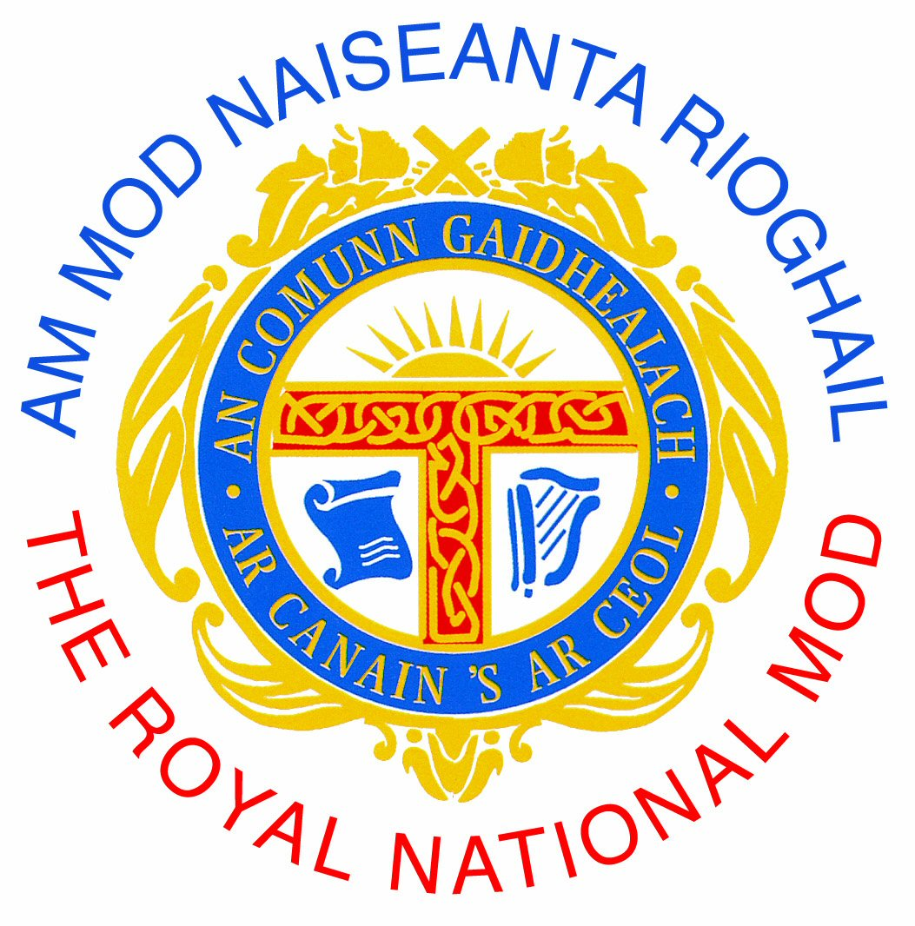

For Office Use

FOIRM ÒIGRIDH

JUNIOR ENTRY FORM

Mòd Phàislig 2013

 |  | Ainm Farpaiseach / Competitor Name*  Ainm Càraid / Duet partner*(If applicable)  Aois & Bliadhna Sgoile air 1 Dàmhair 2013  Age & School Year (if applicable) on 1st Oct 2013*  Ainm Pinn / Pen name (Literary competitions only)  Ainm airson a’ phrògram / Preferred name in programme | Co-là Breith / Date of Birth*
 |  |  | Co-là Breith / Date of Birth*

Sgoil (Innseabh mas e Sgoil Ghàidhlig a th’ ann / School (Please tick if Gaelic medium)

Seòladh / Contact Address

(must be contactable during school holidays)

Còd Puist / Post Code

Seòladh Post-d / E-mail Address (required)

Àireamhan fòn / Tel. Numbers (1 must be a mobile

and contactable during school holidays)
Ainm Stiùiriche / Conductor’s Name
Ainm Còisir / Còmhlan /Choir / Group Name

Àireamh(an) Farpaisean
Competition Numbers (as per syllabus)

Aon Neach / Individual | Càraid / Duet | Còisir / Choir |  | Còmhlan / Group
£5.00 | £6.00 | £10.00 |  | £8.00
 | Cosgais / Entry Fee | £
 | Gu h-iomlan / Total | £

Lìonaibh na leanas ma tha sibh airson pàigheadh le cairt creideis:
The following should only be filled out by those competitors wishing to pay by credit / debit card:
Àireamh Cairt Creideis / Credit Card no.
Ceann latha tòiseachaidh  Start Date  ___/___ | Ceann latha crìochnachaidh Expiry Date  ___/___ | Còd tèarainteachd  (3 àireamhan) / 3 Digit Security Code*  ___________
* The last 3 digits on the signature strip of your card.

PLEASE TICK THIS BOX TO CONFIRM YOU HAVE READ AND UNDERSTAND THE RULES OF
AN COMUNN GAIDHEALACH AND ALL ENTRY DETAILS HAVE BEEN CHECKED

FIOSRACHADH CUDTHROMACH
IMPORTANT INFORMATION

Tillibh am foirm seo agus an airgead gu An Comunn Gàidhealach ro 31 Cèitean 2013.
Entries, together with the appropriate remittance, are to be submitted to An Comunn Gaidhealach before 31st May 2013 by the following means:

Tron doras no anns a’ phost gu / Hand delivered or posted to:

An Comunn Gaidhealach, Taigh Baile an Athain, 40 Sràid Hunndaidh, Inbhir Nis, IV3 5HR
Balnain House, 40 Huntly Street, Inverness, IV3 5HR
Air Post-d gu / E-mailed to entry@ancomunn.co.uk
Tron làrach-lìn / Submitted through the online store: www.ancomunn.co.uk

Bu chòir farpaisich leughadh Riaghailtean a’ Chomuinn Ghàidhealaich mus tèid am foirm seo a lìonadh
The Rules of An Comunn Gàidhealach should be read and followed by all competitors prior to completion of entry forms.
Chìthear na Riaghailtean aig / The Rules can be found on the website: www.ancomunn.co.uk

Feumar pìosan fèin-thaghte a chur a-steach ron 30mh Ògmhios.
All own choice music must be submitted by 30th June.
Mur a cuir, dh’ fhaodadh gun toir An Comunn Gàidhealach 3 comharran bho na comharran gu h-iomlan airson an fharpais.
Failure to submit Own Choice music by the due date may result in 3 marks being deducted by An Comunn from the competitor’s total mark in each relevant competition.

Thèid fiosrachadh / post-d thugaibh a’ dearbhadh gun d’ fhuair sinn na pìosan fèin-thaghte agaibh. Bu chòir dhuibh fìos a chur thugainn mur am faigh sibh dearbhadh.
Receipt of Own Choice music will be acknowledged by e-mail or post. Please contact Office if you have not received an acknowledgement.

Cuimhnichibh cuideachd gum feumar cead fhaighinn ma tha sibh a’ dèanamh leth-bhreac de cheòl a tha leis a’ Chomunn.
Please also note that permission must be obtained prior to photocopying of any sheet music which is copyright of An Comunn.

Airson farpaisean Aon Neach, Càraid agus Còmhlain, feumar 3 leth-bhreac de gach òran (le na facail air an sgrìobhadh mar bhàrdachd), le ceòl agus eadar theangachadh a chuir thugainn.
For Solo, Duet and Folk Group competitions, three copies of words (as a poem) and music for each song, plus translation, must be submitted (unless submitting by email).

Feumar ainm agus àireamh nam farpais a chuir air gach duilleag - facail agus ceòl.
In every case, each copy of the words and music must be clearly marked with the competitor’s name and competition number.

Chan fhaodar bh’ ur pìos fèin-thaghte atharrachadh.
No changes of Own Choice pieces will be accepted.

Thèid an fhiosrachadh seo a chleachdadh taobh a-staigh riaghailtean Àchd Dìon an Fhiosrachaidh. Dh’ fhaodadh gun tèid pàirt den fhiosrachadh seo a sgaoileadh do Mheuran a’ Chomuinn no do bhuidhnean iomchaidh eile.

Mur a bheil sibh airson gun tèid an fhiosrachadh seo a sgaoileadh, cuiribh stràchd dhan bhocsa seo:
The information provided on this form will be used within the terms of the Data Protection Act and may be passed to the appropriate Branch of An Comunn Gàidhealach and other relevant organisations. Should you not wish this information to be circulated, please tick this box.

Chan eil mi / sinn a’ toirt cead airson deilbh / fiolmadh sam bith a thèid a thogail a bhi air an cleachdadh airson adhbharan clàraidh / tasglann a’ Chomuinn Ghàidhealaich.

I / we do not agree to being photographed / filmed for An Comunn Gàidhealach publicity / archiving purposes.

Gheibhear tuilleadh fiosrachadh aig / For further information, visit:
www.ancomunn.co.uk

