Mòd Ionadail Bharraigh is Bhatarsaigh
Barra & Vatersay Provincial Mòd
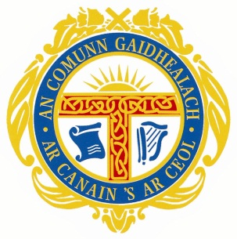
Di-haoine 26mh latha de’n t-Sultain 2014
Di-Sathuirne 27mh latha de’n t-Sultain 2014

Friday 26th September 2014
Saturday 27th September 2014

Syllabus and entry forms are available for download on

http://acgmod.org/localmods/detail/barra

Closing date for all entries is Friday 29th August 2014

For further details or if you can help in any way
contact modbharraigh@aol.com

